13. Drug Concentration and Pharmacological Response
The empirical approach in optimisation of drug therapy was based on relating pharmacological response to the dose administered. There are several drawbacks of such an approach—tedious, time consuming, costly, etc. Moreover, poor correlation may be observed between drug dosage and response since a given dose or a dosing rate can result in large deviations in plasma drug concentration which in most cases are attributable to formulation factors and drug’s elimination characteristics. It is well understood that the response correlates better with the plasma drug concentration or with the amount of drug in the body rather than with the administered dose. Thus, it is easy and more appropriate to design dosage regimens by application of pharmacokinetic principles. The approach is based on the principle that the response produced is proportional to the concentration of drug at the site of action which in turn is reflected in the concentration of drug in plasma. The mathematical relationship between plasma drug concentration and pharmacological response are called as pharmacokinetic-pharmacodynamic modelling (PK/PD modelling).

Problems in Developing PK/PD Relationship
The factors that complicate development of concentration-response relationships are:
- Delay in Drug Distribution: Most sites of action are located in the extravascular tissues and equilibration with drug takes a long time. This results in delay in observation of response. Long delays may occur when the therapeutic response is an indirect measure of drug effect—for example, the anticoagulant effect of dicoumarol is due to indirect inhibition and depletion of clotting factors. Often, the therapeutic action in several such cases outlasts the plasma drug concentration e.g. reserpine.
- Protein Binding: Ideally, the pharmacological response should be correlated with the concentration of unbound drug in plasma since its activity is elicited only by the free form. However, quantification of unbound drug is difficult and thus, if the relationship is based on total plasma drug concentration, any variation in the degree of binding will obscure it.
- Active Metabolites: The metabolites of some drugs such as imipramine and amitriptyline are active which obscure the concentration-response relationship if it is based on the concentration of parent drug. Some drugs such as propranolol form active metabolites on first-pass hepatic metabolism and thus, result in greater response when administered orally than when given intravenously.
- Tolerance: The effectiveness of some drugs decreases with chronic use due to development of acquired tolerance. Tolerance may be pharmacokinetic i.e. through enhanced metabolism e.g. carbamazepine or pharmacodynamic i.e. through diminished response after some period of chronic use e.g. nitroglycerine.
- Racemates: Several drugs are administered as racemic mixture of two optically active enantiomers of which usually one is active; for example, the S(+) isomer of ibuprofen. Hence, a difference in the ratio of active to inactive isomer can lead to large differences in pharmacological response.
Therapeutic Concentration Range
The therapeutic effectiveness of a drug depends upon its plasma concentration. There is an optimum concentration range in which therapeutic success is most likely and concentrations both above and below it are more harmful than useful. This concentration range is called as therapeutic window or therapeutic range. Such a range is thus based on the difference between pharmacological effectiveness and toxicity. The wider it is the more is the ease in establishing a safe and effective dosage regimen. The therapeutic ranges of several drugs have been developed. For many, the range is narrow and for others, it is wide (see Table 13.1).
Table 13.1
Therapeutic Range for Some Drugs
Drug | Disease | Therapeutic Range
Digoxin | Congestive cardiac failure | 0.5 - 2.0 ng/ml
Gentamicin | Infections | 1.0 - 10.0 mcg/ml
Lidocaine | Arrhythmias | 1.0 - 6.0 mcg/ml
Phenytoin | Epilepsy | 10.0 - 20.0 mcg/ml
Propranolol | Angina | 0.02 - 0.2 mcg/ml
Salicylic acid | Aches and pains | 20.0 - 100.0 mcg/ml
 | Rheumatoid arthritis | 100.0 - 300.0 mcg/ml
Theophylline | Asthma | 6.0 - 20.0 mcg/ml
Some drugs can be used to treat several diseases and will have different ranges for different conditions e.g. salicylic acid is useful both in common aches and pains as well as in rheumatoid arthritis. The upper limit of the therapeutic range may express loss of effectiveness with no toxicity e.g. tricyclic antidepressants or reflect toxicity which may be related to pharmacological effect of the drug e.g. hemorrhagic tendency with warfarin or may be totally unrelated e.g. ototoxicity with aminoglycosides.
Concentration-Response Relationships – Pharmacodynamic Models
With most drugs, the response produced is reversible i.e. a reduction in concentration at the site of action reverses the effect. The response produced by a drug can be classified into two categories –
- Graded response - is the one where intensity of effect increases with the dose or concentration of drug. A majority of drugs produce graded response. The response can be measured on a continual basis in such cases and establishing a linear relationship between drug concentration and intensity of response is easy.
- Quantal Response – is the one where the drugs may either show their effect or not at all i.e. the responses are not observed on a continuous basis, for example, prevention of seizures by phenytoin. Such responses are also called as all-or- none responses. Thus, establishing a concentration-response relationship in such circumstances is difficult but can be developed in terms of the frequency with which a particular event occurs at a given drug concentration.
Mathematical models that relate pharmacological effect to a measured drug concentration in plasma or at the effector site can be used to develop quantitative relationships. Such models are often called as pharmacodynamic models. Some of the commonly used relationships or models are discussed below.
1. Linear Model: When the pharmacological effect (E) is directly proportional to the drug concentration (C), the relationship may be written as:
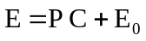 | (13.1)
where P is the slope of the line obtained from a plot of E versus C and Eo is the extrapolated y-intercept called as baseline effect in the absence of drug.
2. Non-linear/Logarithmic Model: If the concentration-effect relationship does not conform to a simple linear function, a logarithmic transformation of the data is needed.
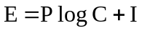 | (13.2)
where I is empirical constant. This transformation is popular because it expands the initial part of the curve where response is changing markedly with a small change in concentration and contracts the latter part where a large change in concentration produces only a slight change in response. An important feature of this transformation is the linear relationships between drug concentration and response at concentrations producing effects of between 20 to 80% of the maximum effect (Fig. 13.1). Beyond this range, a larger dose produces a larger concentration of drug in the body.
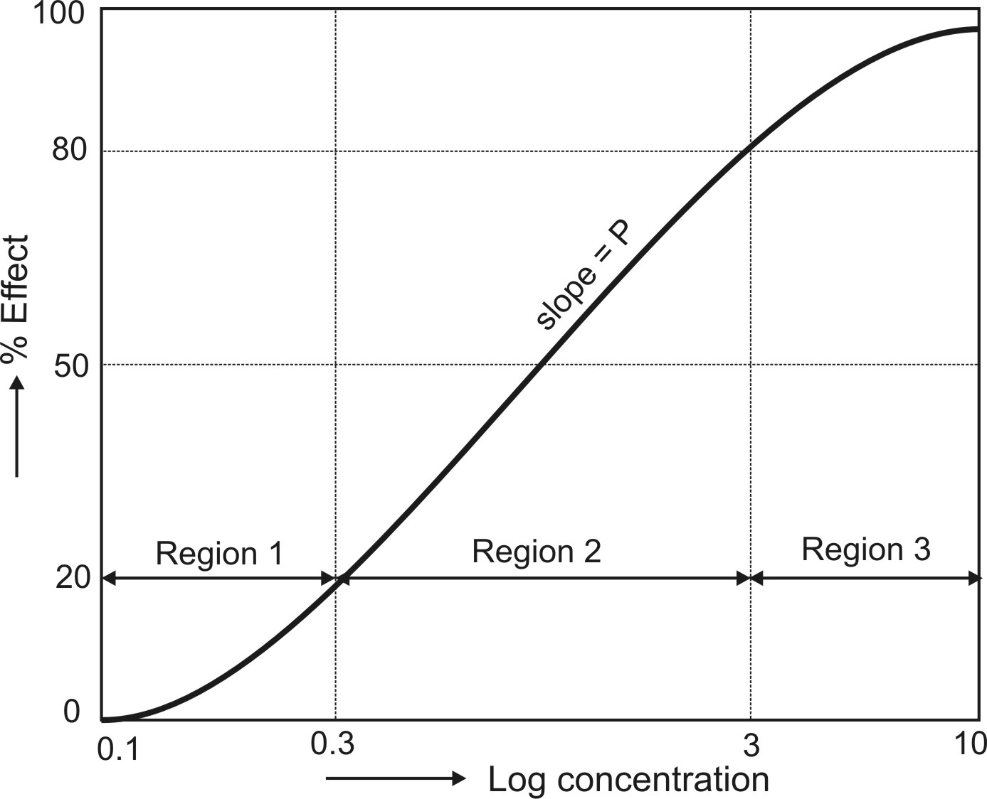
Fig. 13.1 A typical sigmoidal shape log drug concentration-effect relationship
3. Emax Model/Hyperbolic Model: Unlike earlier models, these models describe non-linear concentration-effect relationships i.e. the response increases with an increase in drug concentration at low concentrations and tends to approach
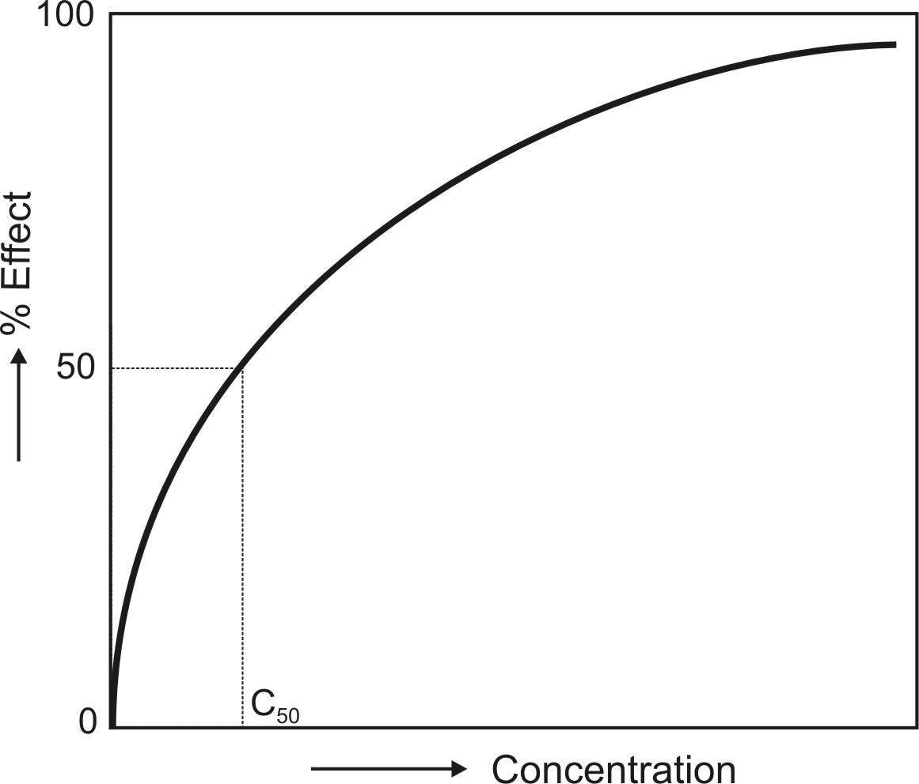
Fig. 13.2 A hyperbolic concentration-response relationship based on Emax model
maximum (asymptote) at high concentrations (Fig. 13.2). Such a plot is characteristic of most concentration-response curves. None of the preceding models can account for the maximal drug effect as the Emax models.
Michaelis-Menten equation for a saturable process (saturation of receptor sites by the drug molecules) is used to describe such a model.
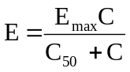 | (13.3)
where
Emax = maximum effect, and
C50 = the concentration at which 50% of the effect is produced.
When C << C50, the equation reduces to a linear relationship. In the range 20 to 80%, the Emax model approximates equation 13.2.

4. Hill Model/Sigmoid-Emax Model: In certain cases, the concentration-response relationship is steeper or shallower than that predicted from equation 13.3. A better fit may otherwise be obtained by considering the shape factor ‘h’, also called as Hill coefficient, to account for deviations from a perfect hyperbola, and the equation so obtained is called Hill equation (equation 13.4).
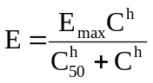 | (13.4)
If h = 1, a normal hyperbolic plot is obtained and the model is called Emax model. Larger the value of h, steeper the linear portion of the curve and greater its slope. Such a plot is often sigmoidal and thus, the Hill model may also be called as sigmoid-Emax model (Fig. 13.3).
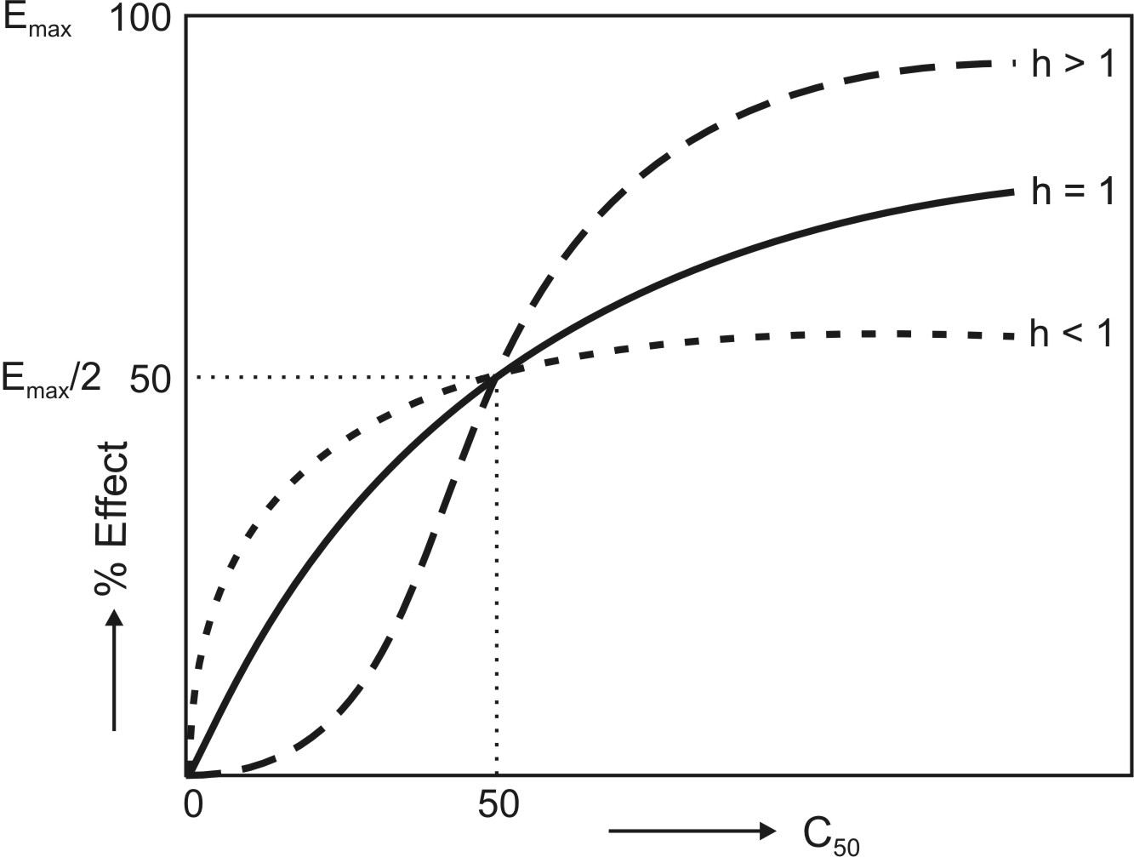
Fig. 13.3 Effect of shape factor n on the concentration-response curves
Onset/Duration of Effect-Concentration Relationships
The onset of action of a drug that produces quantal response occurs when a minimum effective level of drug in the plasma Cmin is reached. The duration of action of such a drug will depend upon how long the plasma concentration remains above the Cmin level.
The factors which influence duration of action of a drug are:
1. The dose size, and
2. The rate of drug removal from the site of action which in turn depends upon the redistribution of drug to poorly perfused tissues and elimination processes.
An increase in dose promotes rapid onset of action by reducing the time required to reach the Cmin and prolongs the duration of effect. The influence of dose on duration of action can be explained as follows. Consider a drug that distributes rapidly (one-compartment kinetics) and administered as i.v. bolus dose. The plasma drug concentration is given by the equation:
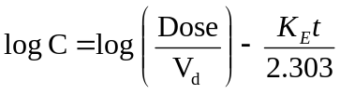 | (13.5)
The plasma concentration falls eventually to a level Cmin below which the drug does not show any response. At this time, t = td, the duration of effect of a drug. The above equation thus becomes:
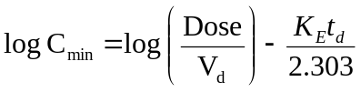 | (13.6)
Rearranging to define duration of effect, the equation is:
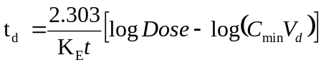 | (13.7)
where CminVd = Xmin, the minimum amount of drug in the body required to produce a response. A plot of td versus log dose yields a straight line with slope 2.303/KE and x-intercept at zero duration of effect of log Xmin (Fig. 13.4).
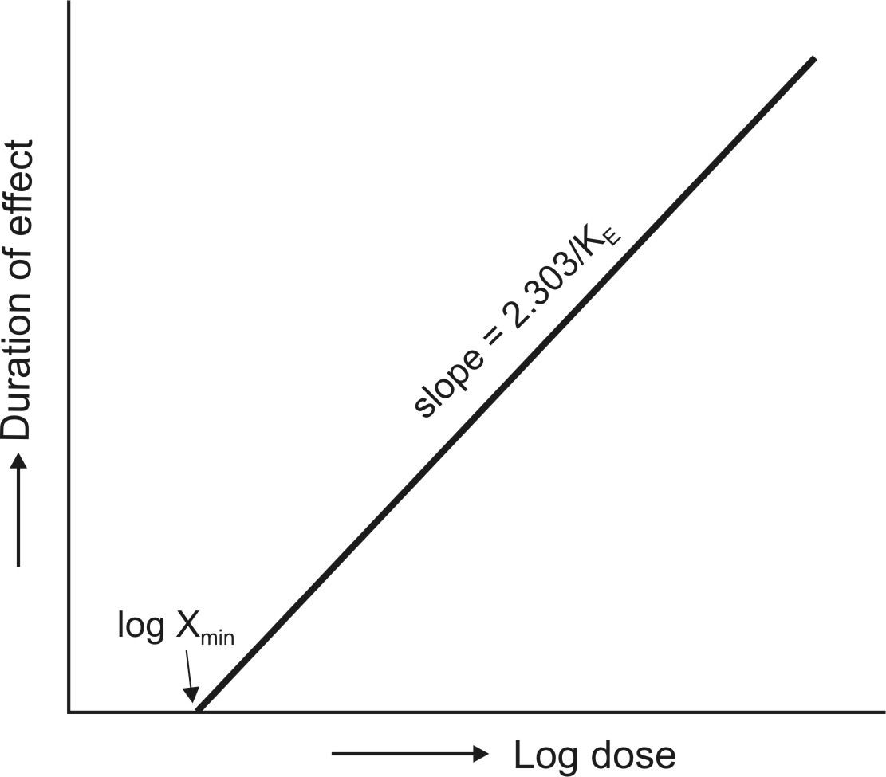
Fig. 13.4 Relationship between dose of drug and duration of action
Equation 13.7 shows that the duration of effect is also a function of t½ (0.693/KE). With each doubling of dose the duration of effect increases by one half-life. This can be explained by considering that a dose Xo produces a duration of effect td; so when double the dose i.e. 2Xo is administered, the dose remaining after one half-life will be Xo which can produce a duration of effect equal to td. Thus, the total duration of effect produced by 2Xo will be t½ + td. However, the approach of extending the duration of action by increasing the dose is harmful if the drug has a narrow therapeutic index. An alternative approach is to administer the same dose when the drug level has fallen to Xmin. Thus, after the second dose, the drug in the body will be (dose + Xmin). If Xmin is small in relation to dose, very little increase in duration of action will be observed.
Intensity of Effect-Concentration Relationships
In case of a drug that produces quantal response, the pharmacodynamic parameter that correlates better with its concentration is duration of action. The parameter intensity of response is more useful for correlation with the concentration of a drug that shows graded effect. Like duration of action, intensity of action also depends upon the dose and rate of removal of drug from the site of action. The intensity of action also depends upon the region of the concentration-response curve (refer Fig. 13.1). If a drug with rapid distribution characteristics is given as i.v. bolus dose large enough to elicit a maximum response, the log concentration-response plot obtained will be as shown in Fig. 13.1. The relationship between dose, intensity of effect and time can be established by considering the plots depicted in Fig. 13.5. which also shows 3 regions.
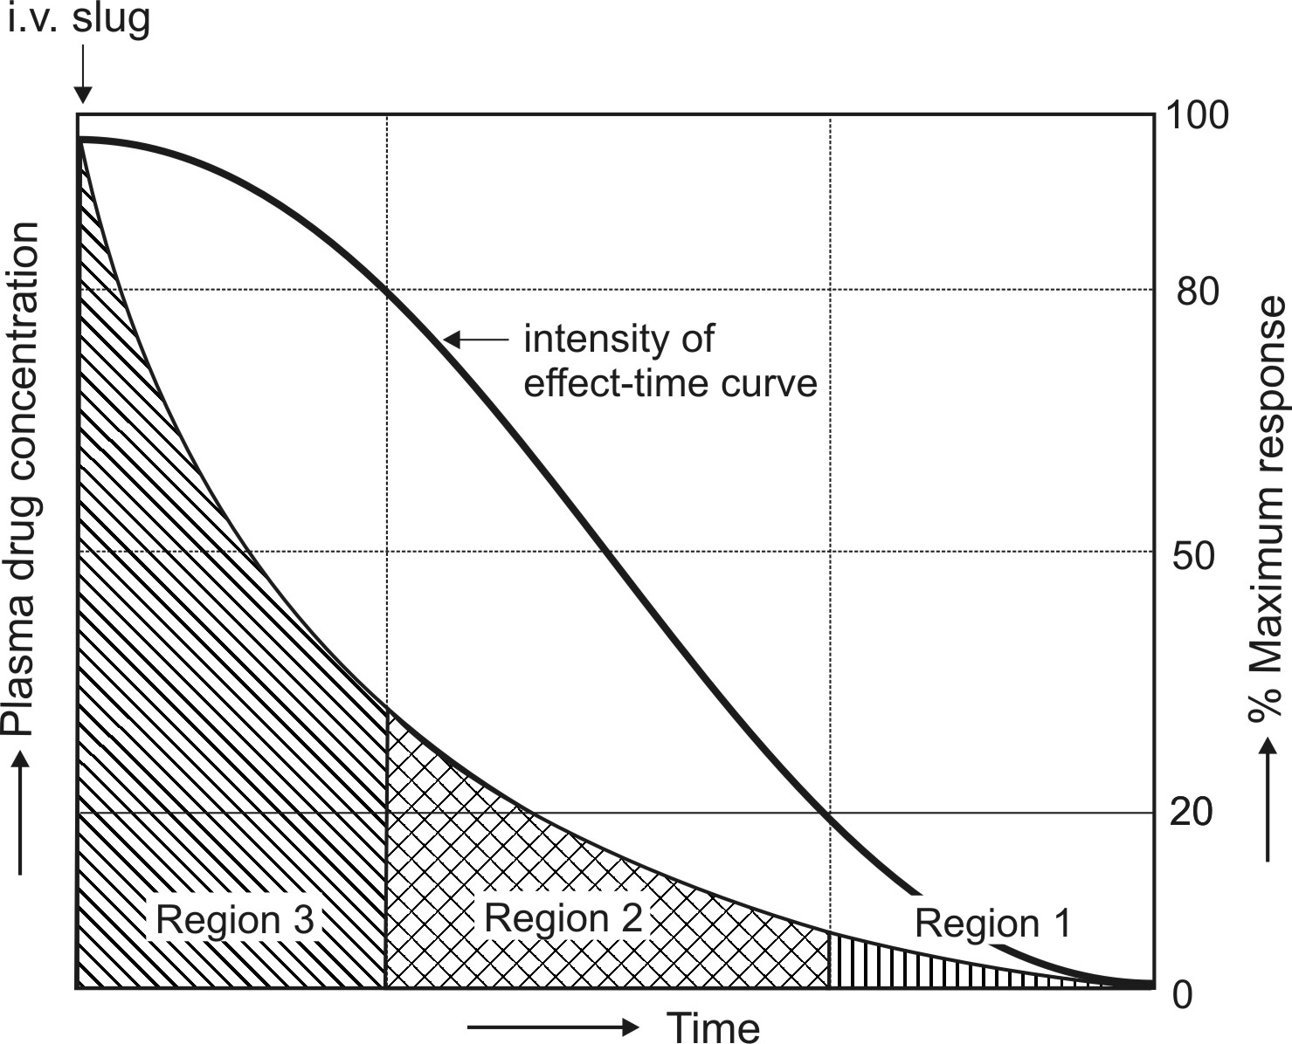
Fig. 13.5 The fall in intensity of response with drug concentration and with time following administration of a single i.v. bolus dose.
Region 3 indicates 80 to 100% maximum response. The initial concentration of drug after i.v. bolus dose lies in this region if the dose injected is sufficient to elicit maximal response. The drug concentration falls rapidly in this region but intensity of response remains maximal and almost constant with time.
Region 2 denotes 20 to 80% maximum response. In this region, the intensity of response is proportional to log of drug concentration and expressed by equation 13.2.
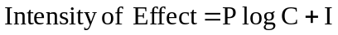 | (13.2)
Since the decline in drug concentration is a first-order process, log C can be expressed as:
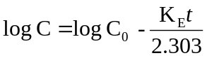 | (13.8)
Substituting 13.8 in equation 13.2. and rearranging we get:
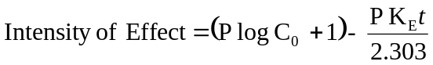 | (13.9)
If Eo is the intensity of response when concentration is Co, then:
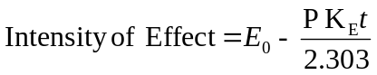 | (13.10)
Equation 13.10 shows that the intensity of response falls linearly (at a constant zero-order rate) with time in region 2. This is true for most of the drugs. The drug concentration however declines logarithmically or exponentially in region 2 as shown by equation 13.8.
Region 1 denotes 0 to 20% maximum response. In this region, the intensity of effect is directly proportional to the drug concentration but falls exponentially with time and parallels the fall in drug concentration.
QUEsTIONS
1. Why is it that the pharmacological effect of a drug shows better correlation with its plasma concentration than with its dosage?
2. What are some of the more important causes of poor correlation between plasma drug concentration and pharmacological response?
3. Define therapeutic range. What does plasma drug concentration beyond this range signify?
4. Define: (a) Graded response, and (b) Quantal response.
5. What are pharmacodynamic models? Discuss some of the more important models used to quantify plasma concentration-response relationships.
6. When does onset of action occur for a drug that shows graded response and for the one that elicits quantal response?
7. On what factors do duration and intensity of drug action depend?
8. Explain how with each doubling of dose, the duration of effect increases by one half-life for a drug that elicits graded response.
9. When and why is it not advisable to extend the duration of action by increasing the dose? What is the alternative in such cases?
10. How does intensity of drug action change with its plasma concentration?
11. The C50 of a drug showing graded response is 5 mcg/ml and has a shape factor n of 2.0. Calculate the concentration range if the drug is found to be effective when the response is between 20 to 80% of the maximal value. (Hint: Take reciprocal of equation 13.4 and express intensity of effect as 0.2 Emax and solve to obtain C20. Similarly, take it next as 0.8 Emax and solve to determine C80)
Answer : C20 = 2.5 mcg/ml and C80 = 10.0 mcg/ml.
12. Mezlocillin has a MEC of 5 mcg/ml for a particular infection when given i.v. in a bolus dose of 2.5 mg/Kg. What will be the duration of effect if a dose of 50 mg/Kg is administered? The drug has a half-life of 0.8 hours. What will be the duration of effect if the dose is doubled? Is the increase in duration of action equal to one half-life?
Answer : 3.5 hours and 4.3 hours.
13. A newly developed antihypertensive drug shows linear relationship between intensity of effect and log drug concentration. After i.v. administration of 0.15 mg/Kg dose, the observed reduction in blood pressure with time is shown in the table below:
Time (hours) 0.5 3.0
% Reduction in B.P. 45.0 40.0
Given : P = 20.0%
a. What is the half-life of the drug? (Hint: Use equation 13.12 for a plot of intensity of effect versus time and compute values from slope) Answer : t½ = 3 hours.
b. What will be the % intensity of response immediately after injection of drug?
Answer : 46.0%.
c. How long is the reduction in B.P. expected to remain above 20.0% of maximum response?
Answer : 13 hours.

